# POC 31

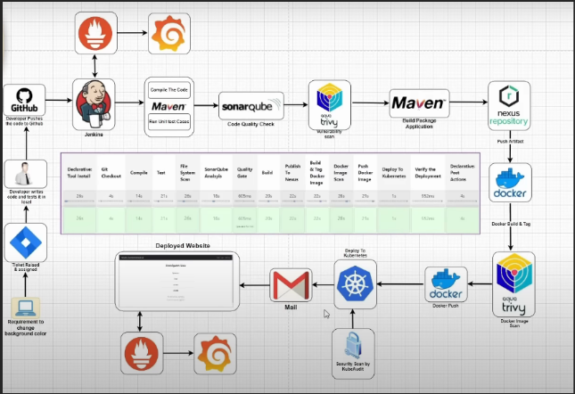

**1. Setup Source Code Repository (GitHub)**

* Java application using Maven
* Include:
  + Dockerfile
  + k8s/deployment.yaml

**2. Setup Jenkins**

* Install required plugins: Git, Pipeline, Maven, SonarQube
* Install on VM (e.g., EC2 or local)
* Ensure Jenkins agent has:
  + Docker
  + AWS CLI
  + kubectl
  + Trivy

**3. Setup SonarQube**

* Install and run SonarQube (via Docker or VM)
* Create a new project and generate a token
* Configure token in Jenkins as sonar-token

**4. Setup AWS Services**

* 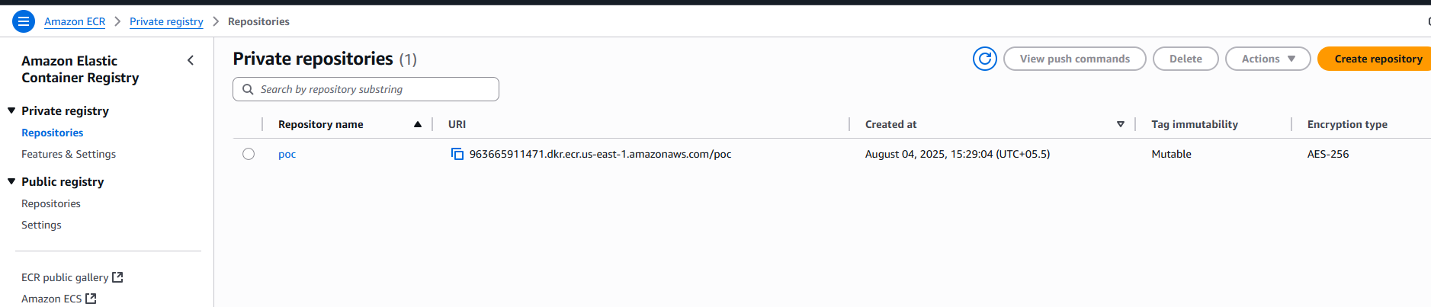**ECR**: Create a repository (e.g., poc)
* **EKS**: Create and configure a Kubernetes cluster
  + Use kubectl to connect

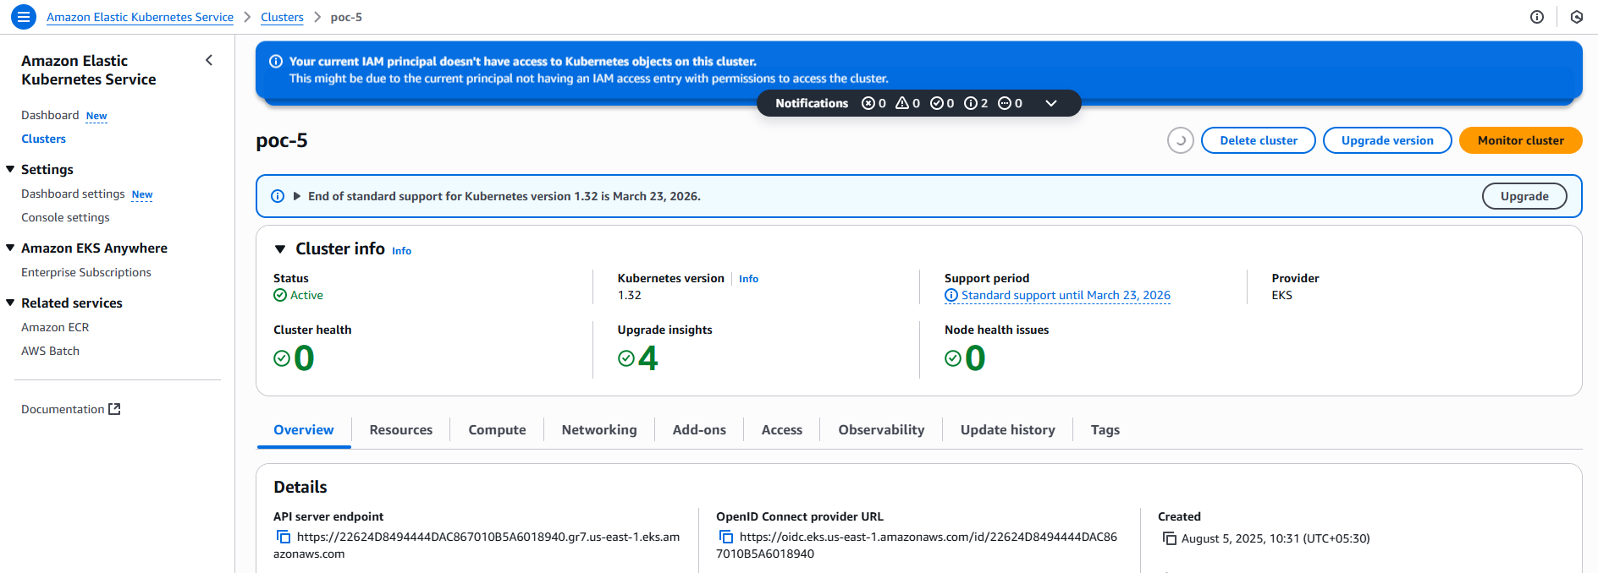

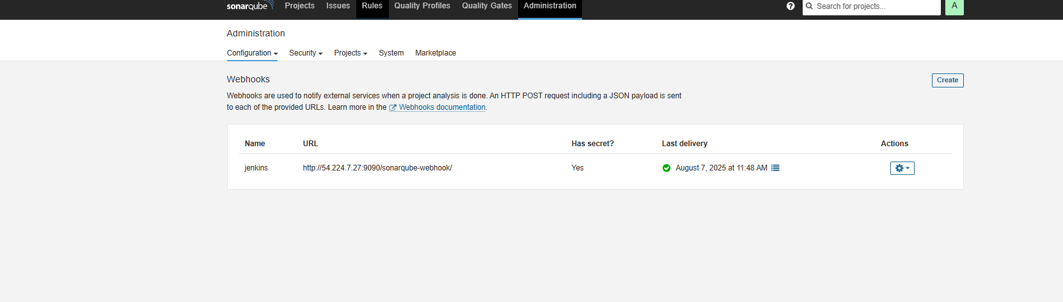**5. Setup a sonar Qube and setup a Webhook**

**6. Jenkins Credentials**

* Add the following Jenkins credentials:
  + sonar-token: SonarQube access token
  + aws-access-key: AWS IAM user access key
  + aws-secret-key: AWS IAM user secret key

**7. Connect Jenkins to SonarQube server**

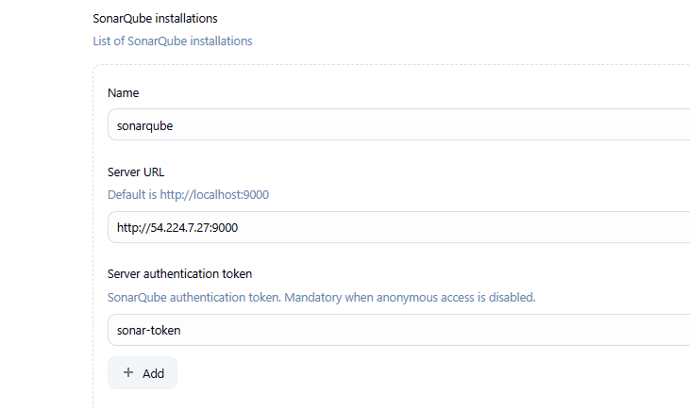

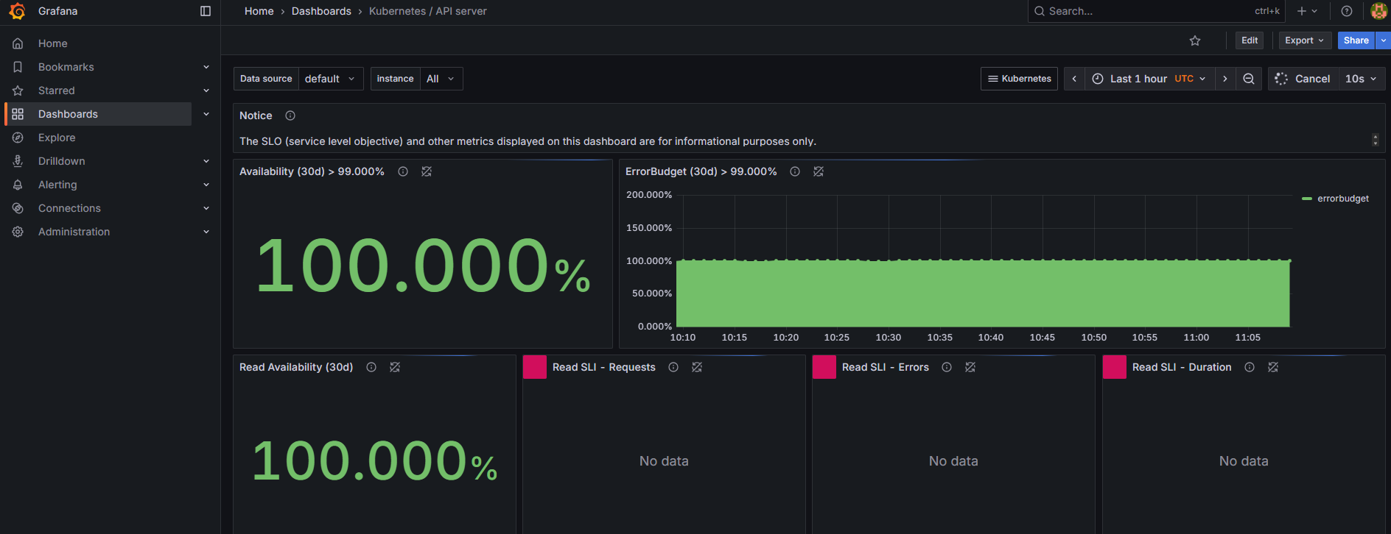8. Install the Prometheus and Grafana

9.Setup a Jenkins pipeline with below steps.

| **Stage** | **Description** |
| --- | --- |
| Git Checkout | Pulls code from GitHub |
| SonarQube Analysis | Performs code quality checks |
| Quality Gate | Verifies SonarQube results |
| Docker Build | Builds Docker image from code |
| Trivy Scan | Scans image for vulnerabilities |
| Push to ECR | Pushes image to AWS ECR |
| Deploy to EKS | Replaces tag and deploys app to Kubernetes |

Final Output:

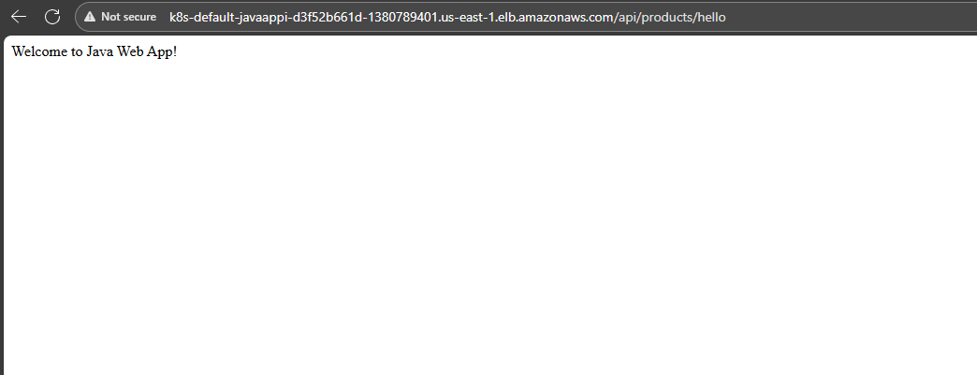

Issue :

After restart public IP was changed and which caused the issue in the Jenkins so have to update the up in below file

/var/lib/jenkins/jenkins.model.JenkinsLocationConfiguration.xml